- Purpose
The Supplier International Shipping Instructions defines the steps to ensure the timely moving of goods to Access Business Group (ABG) or Amway location.
- Scope
The procedure applies to all ABG-managed international shipments from a supplier to an ABG or Amway location.
- Procedure
  - Shipping Process Overview
The supplier receives a purchase order from Access Business Group (ABG) Procurement and schedules production.
Once the product is produced, the material will undergo a QA review to ensure the product adheres to the previously agreed upon specifications.
Note: For new suppliers and first-time purchase orders / production runs, the net weights and gross weights of the items must be verified with ABG Planning and Procurement contacts. After approval from ABG Planner, all gross weights and net weights must remain consistent throughout the product lifecycle. This will help prevent inconsistencies between the Supplier Letterhead documents and the ABG Letterhead commercial shipping documents.
Net weight represents the weight of the selling unit and the gross weight represents the selling unit plus “throw away” packing material.
*Please note that the gross weight does not include the pallet weight
For all completed purchase orders, the supplier is required to send a Commercial Invoice and Packing List on the Supplier Letterhead.
The supplier must provide adequate advanced notice of desired load date, in compliance with the previously agreed upon delivery date shown on the Purchase Order.
  - Booking Process with ABG’s Global Freight Forwarder, Expeditors
Suppliers should reach out to the Expeditors International local office to place booking request following the below guidelines. Doing so, will allow Expeditors sufficient time to arrange pick-up and confirm a booking with the steamship line / Airline.
- Ocean: 4-6 weeks prior to cargo ready date
- Air: 5 days prior to cargo ready date
A comprehensive list of the local Expeditors International offices can be found at www.expeditors.com. You can also reach out to our Expeditors Account Manager team to confirm local contact details.
Expeditors Global Account Management Team
Origin Region | Account Manager | Email
Americas | Noah Ketz-Munoz | Noah.ketz-munoz@expeditors.com
APAC | Frank Yoh | Frank.yoh@expeditors.com
China | Peggy Pang | Peggy.pang@expeditors.com
India | Rajat Rekhi | Rajat.rekhi@expeditors.com
Europe | Tony O’hare | Tony.OHare@expeditors.com
Americas | Pablo Prieto | Pablo.prieto@expeditors.com

At the time of booking, suppliers must provide Expeditors with the below shipment details. Please note details can be estimated and revised as needed prior to Cargo Ready Date.
- Full Container Loads
  - Cargo Ready Date
  - FCL: Equipment QTY and Type: (e.g. 1x40, 2x20)
  - LCL : Pcs / WT / cbm
  - Incoterm (FCA or FOB)
  - Origin and Destination
  - ABG PO#
- Air Shipments
  - Cargo Ready Date
  - Pieces (e.g. Pallets or Master cartons)
  - Dimensions of the pallets or Master Cartons
  - Estimated Total Gross weight
  - Incoterm
  - Origin and Destination
  - ABG PO #
Once the booking request is sent, Expeditors will be able to provide the booking confirmation once confirmed by carrier. If Expeditors is handling the pick-up they will provide the supplier with a pick up order once confirmed.
It is recommended that bookings be made through Expeditors Order Management Booking (OMB) Tool. Instructions on the use and set-up of the tool can be found in the OMB Shipping Guide available in the Transportation section of the supplier.amway.com portal.

Prior to export, the supplier is required to send the below documents to Expeditors via OMB or email.

- Commercial Invoice
- Packing List
- Any other related documents for clearance (COO, wood declaration, etc.)

Note:

- ABG enforces a “No Docs / No Ship Policy”
- Accepted INCOTERMS are FCA: Supplier’s Door or FOB: Port of Export
- The Supplier is always responsible for any export formalities

  - Supply Chain Security Requirements
ABG is a certified member in the U.S. “Customs-Trade Partnership Against Terrorist” (C-TPAT) and strongly urges Suppliers to adopt the security standards of this program, or the equivalent supply chain security program criteria administered by the Customs administration in the Supplier’s home country. C-TPAT sec security requirements can be found by accessing the following US Customs website: https://www.cbp.gov/border-security/ports-entry/cargo-security/ctpat
As outlined in the US Customs website, the Supplier agrees to take such reasonable measures as may be required by ABG to ensure the physical integrity and security of all shipments to ABG / Amway against the unauthorized introduction of harmful or dangerous materials, drugs, contraband, weapons or weapons of mass destruction, or introduction of unauthorized personnel in transportation conveyances or containers. Such measures may include, but are not limited to, physical security of manufacturing, packing and shipping areas, restrictions on access of unauthorized personnel to such areas: personnel screening as is appropriate in supplier’s or manufacturer’s country: and development, implementation and maintenance of procedures to protect the security and integrity of all shipments.
Note: For new suppliers and first time purchase supplier to complete attached supply chain security questionnaire and return to Erin.Milito@Amway.com
Palletization
If shipping on pallets, the pallets must be securely shrink-wrapped and labeled according to the Package Identification Requirements procedure. Any damage that results from inadequate packaging will be the responsibility of the Supplier.
Wood Declaration
If solid wood is used in packaging, all pieces must be ISPM15 compliant and contain the IPPC stamp.
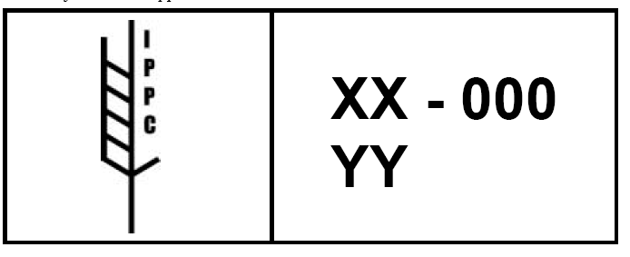
ISPM 15 applies to coniferous (softwood) and non-coniferous (hardwood) raw wood packaging material. This includes dunnage, crating, packing blocks, drums, spools, cases, load boards, pallet collars, skids, pallets, and other wood units used to secure cargo or a commodity.
  - Loading of Container
The supplier must inspect the trailer/container to ensure it is clean and in good condition. Do not load any trailer/container that shows visible signs of potential damage to product (i.e. holes inside/top/floor, dirty floor, bad odor, etc).
Carefully document actual product SKU/Quantity/Lot Code/AMC Code, PO# and PO line # loaded onto the trailer/container, as identified on the Proforma Packing List.
In order to avoid damage during transit, product that is loaded must be properly blocked and braced to avoid cargo from shifting.
Apply high security ISO 17712 bolt seal to door of any full container shipment once loading is completed
Complete container loading within designated load free time (typically 2 hours following trailer/container arrival at Supplier)
For full containers loaded outside of the U.S. at the Supplier’s facility and being shipped directly to any Access Business Group U.S. location, suppliers are required to provide written certification to Access Business Group that the supply chain security requirements of U.S. Customs and Border protection for importers have been met. The supplier can provide a blanket certification for all shipments that will follow or provide a certificate for each specific shipment.
Suppliers must take a photo of completed load, for all full container shipments and keep this available if requested by ABG.
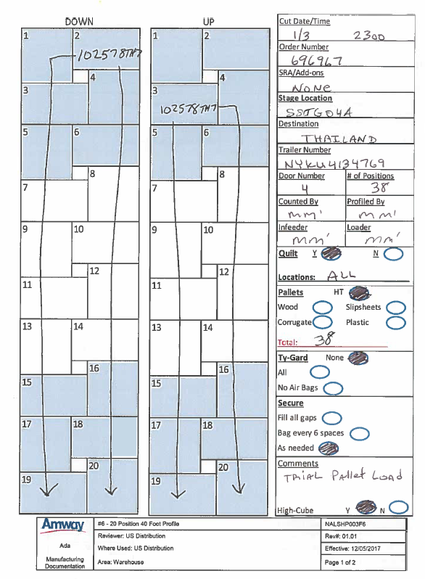
Suppliers are required to present a container load plan for full containers loaded at the Supplier’s facility in the document package. A container load plan must also be included in the container. An envelope labeled “Container Load Plan” should be taped to a carton located at the container door. Container Load Plan Diagram Example:

  - International Shipping Documents
All required documentation outlined below should be turned over to the ABG Planner within 2 Days of Loading
Commercial Invoice must contain the following:
- ABG PO# and PO Line # (i.e. 44314OP Line 01)
- Name AND location of the business or person selling the merchandise
- Name AND Location of buyer of the merchandise (typically ABG)
- The U.S. address of the person or business the goods are being shipped to
- ABG sku#
- Describe the item clearly - a detailed description of the merchandise in English
- Country of Origin (where the item was manufactured)
- Value of the items (unit price)
- Currency
- Quantity, weights and measurements
  - Example: net weight in kilograms by line item
- All additional charges that will be billed to Amway. Accounted by name and amount (i.e. freight, pallet charges, productions charges, etc.)
- The invoice and all attachments must be in the English language
Packing List must contain the following:
- Country of Export
- Net Weight
- Gross Weight (excluding pallets)
- SKU#
- Description of Product (must be identical to the description on the PO)
- Specification (If shipping spare parts, the name of the equipment on which they will be used)
- PO # and release
- QTY and Pieces
- Number of Master Cartons
- QTY per Master Carton
- QTY per Pallet (if applicable)
- Number of Pallets and Pallet Weight
- Number of Partial Cartons and quantity
- List of assigned lot codes and quantity per lot code (formulated products only)
- Container # or other Carrier Reference #
Value Declaration (if applicable)
Certification of Origin (Form A)
No Wood Declaration or Wood Certification (if applicable)
Container Load Plan/Diagram (Mandatory for full container loads)
Certificate of Analysis (if applicable)
NOTE: ABG has instructed all ocean carriers to issue Express Sea Waybills (ESW) instead of Original Bills of Lading, except where it is a government requirement
Detention / Container Storage Charges:
If any of the aforementioned documents are incorrect, incomplete or inaccurate due to the fault of the Supplier, the Supplier shall be responsible for any additional charges incurred (i.e. container detention charges, storage charges, customs penalty, warehousing charges.)

  - Labeling Requirements for Amway Thailand
Supplier is required to tag the shipping mark as per below.
- Shipping Mark: AMWAY
- Ship mode LCL and Air: Tag on the actual cargo (usually on pallet, not on the product)
- Ship mode FCL: Tag inside of the container door
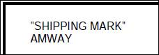

  - Main Points of Contact
ABG International Transportation:
Contact: Kristin Kelly
E-Mail: kristin.kelly@amway.com
Tele: 616-787-6255
ABG Global Trade:
Contact: Adam Whitney
E-Mail: adam.whitney@amway.com
Tele: 616-787-7834

