 | Topic Area | Revision Date
 | These instructions are intended only for only COLLECT orders/shipment under 150 lbs. | Jul-25
 | FedEx Ground Collect Training

- Login to https://www.fedex.com/en-us/home.html.
  - If you do not already have a User ID and password, click the “CREATE A USER ID” option and provide the necessary information.
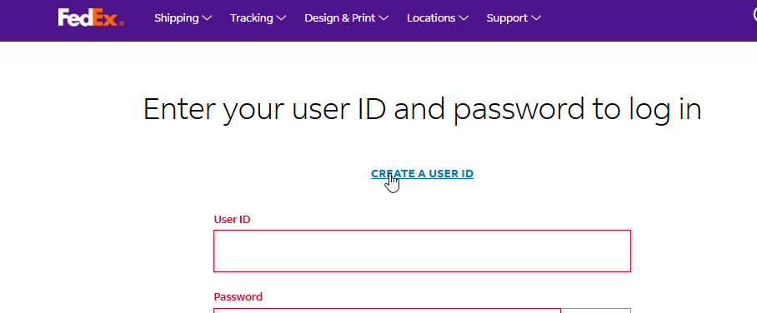
- Once logged in, hover over the Shipping drop down menu and select “Create a Shipment”
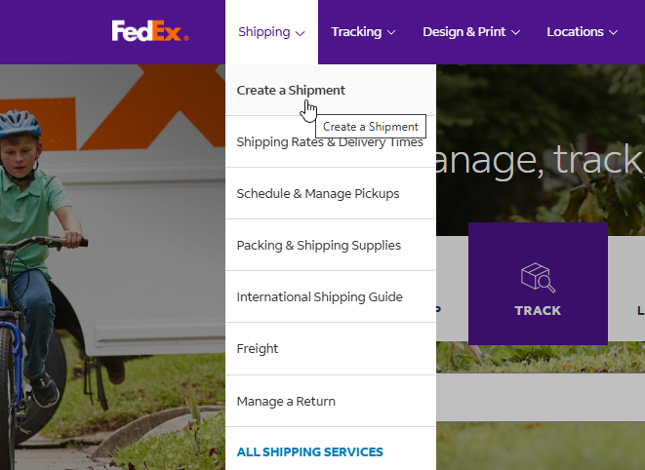

- From there, please utilize the below guide to assist you in creating a shipment
- Please refer to the Q&A portion on pages 8-9 for further information

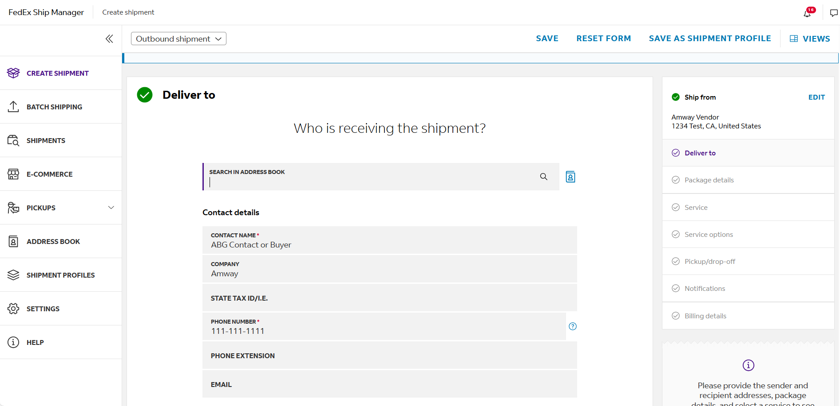
Click next to move to shipment details screen
Your company’s info populates here
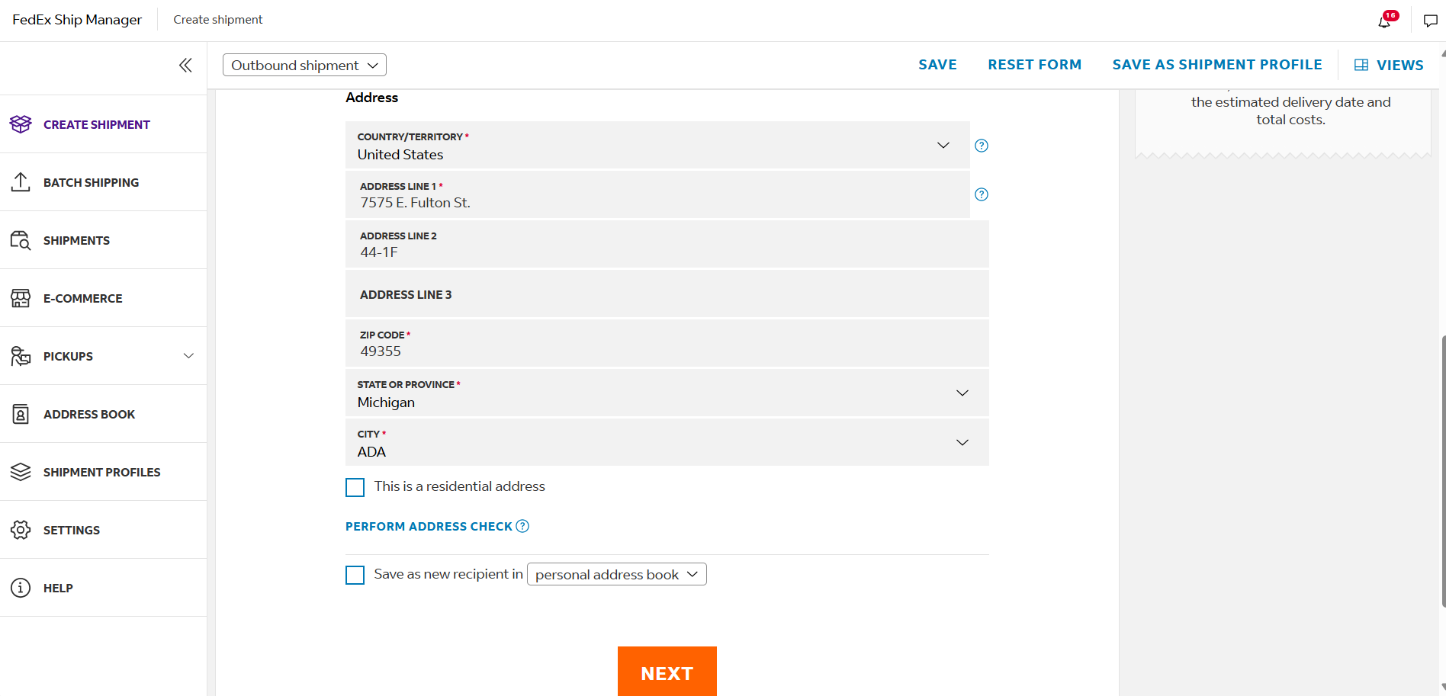
Please key in address as shown below and include your ABG Contact Name above

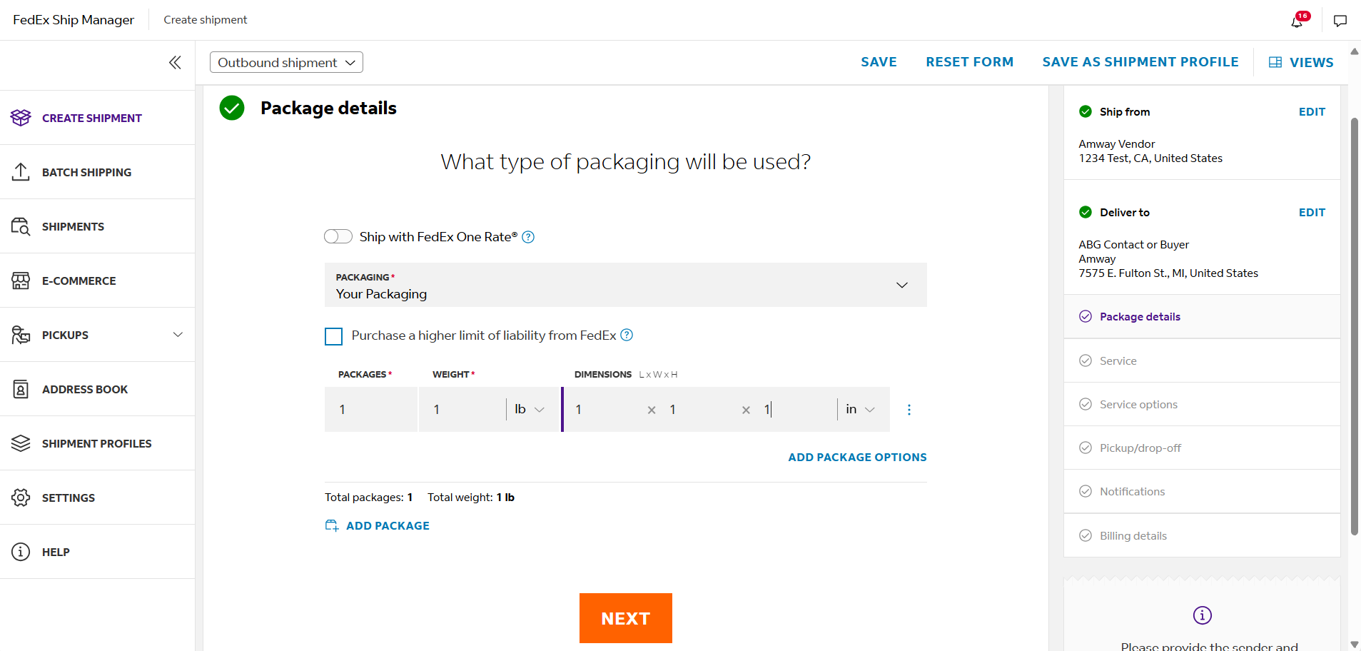
Choose “Your packaging” and enter appropriate weight and dimensions of the package below, then click next
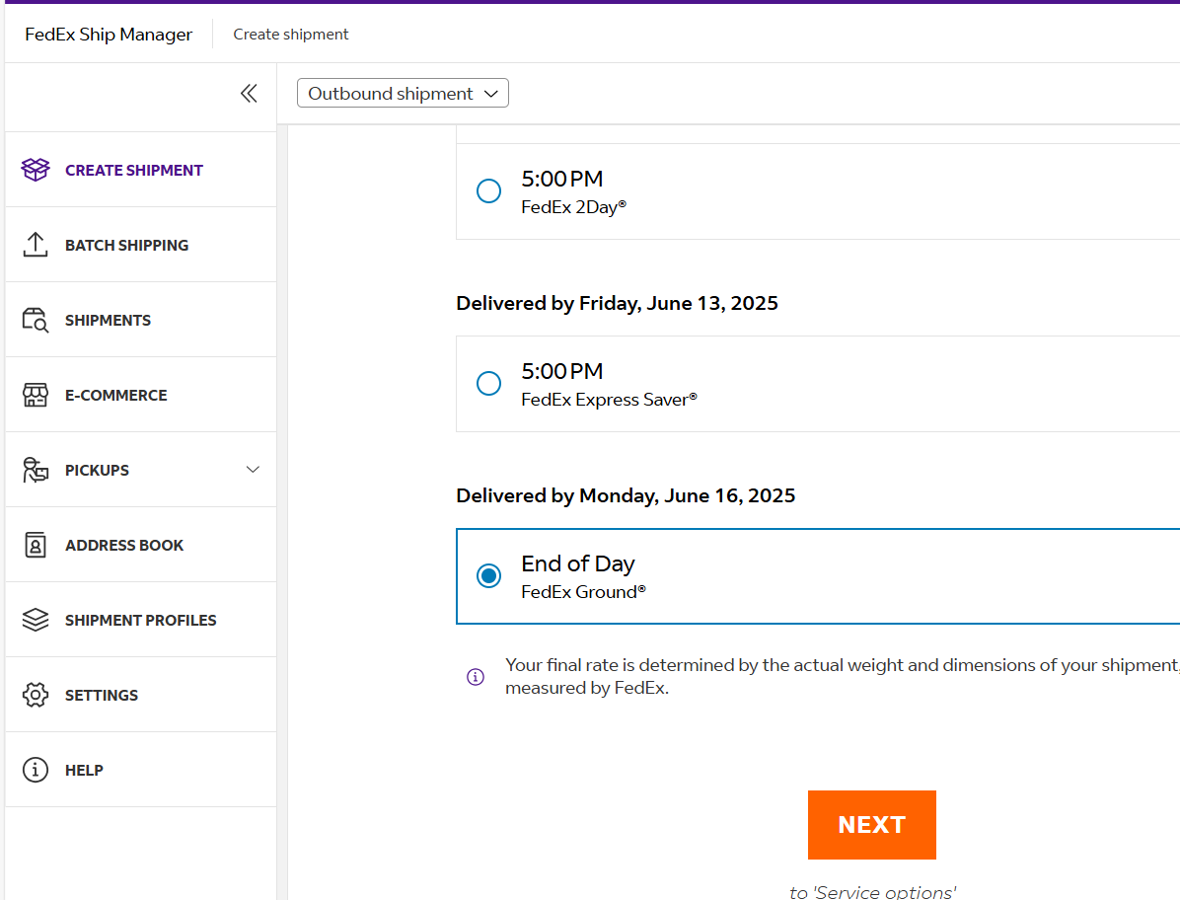
Select FedEx Ground as the service type and then click next to go to next screen

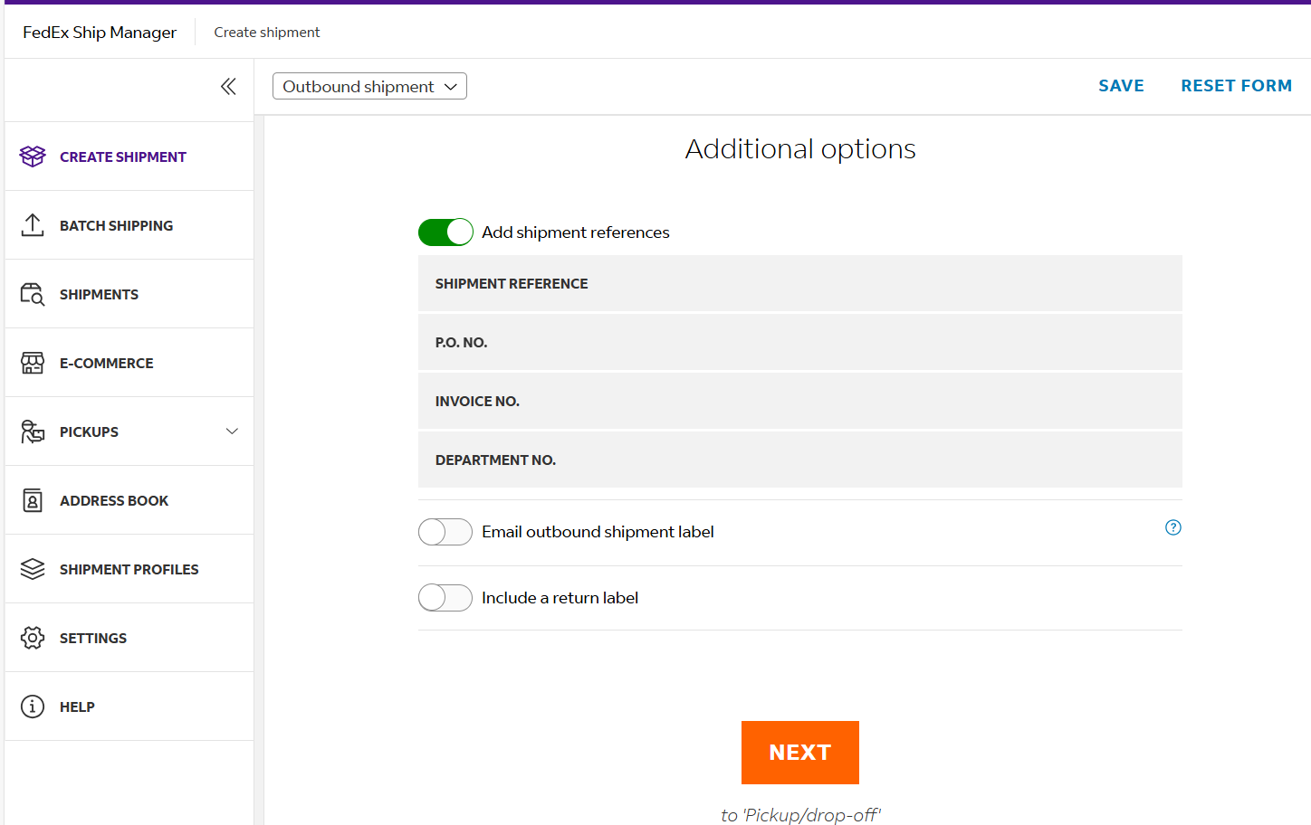
Please key in the Amway PO and any shipment specific reference numbers required in these fields, then click next

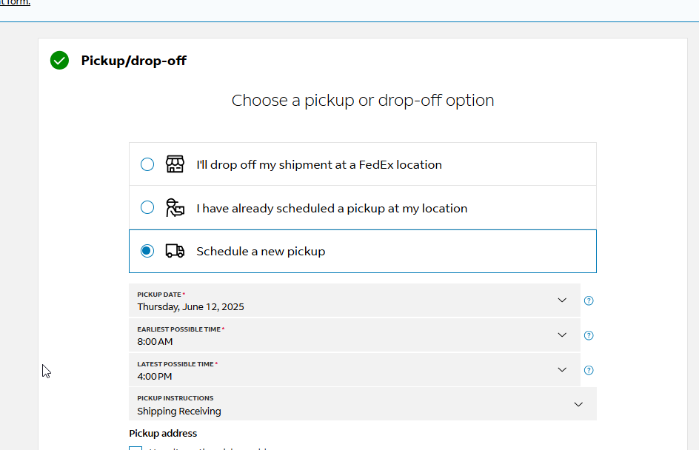
Choose which method you would like to tender the package to FedEx. Most shippers will want to select the “Schedule a new pickup” option. Be sure to include the pick-up date and shipping hours. If you have location specific instructions for the driver, be sure to include those as well.

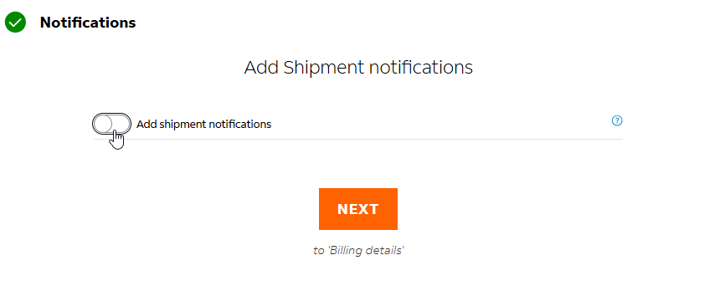
In the drop-down menu in the billing details screen, choose Collect (Authorized Ground Accounts Only)
You may choose to add shipment notifications if you’d like by adding an email address on this screen. Otherwise, you can click next to advance to the final steps
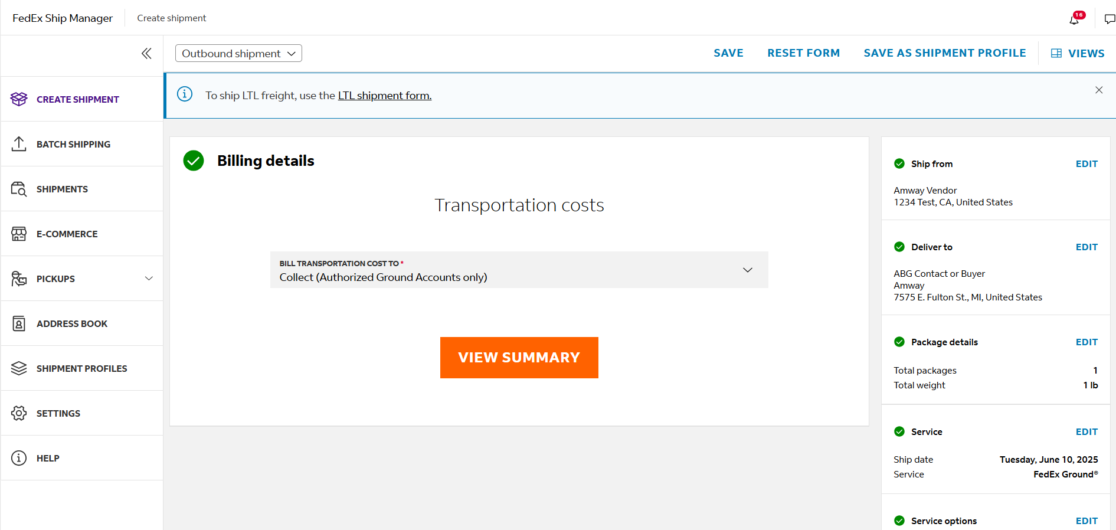

Click on View Summary and then you can finalize the shipment and print shipping labels.

FedEx Ground®
COLLECT FAQs
for Suppliers

Q. How do I get started with FedEx Ground COLLECT?
A. There are no special account setup requirements for the FedEx Ground COLLECT shipper; you use it through FedEx Ship Manager® at fedex.com. All you need to get started is a FedEx account number that has been enabled to ship via FedEx Ground.

Q. I don’t have a FedEx account. How can I get one?
A. If you don’t have a FedEx account or your existing account is not enabled for FedEx Ground® service, call 1.800.GoFedEx 1.800.463.3339 and say “new account setup.” Your FedEx account executive can also help you obtain an account.

Q. How can I sign up for FedEx Ship Manager at fedex.com?
A. Go to fedex.com and from the home page click on Create Shipment under the Ship tab. You’ll see a section called “New fedex.com Users”. Click on Sign Up Now to register for a user ID and password.

Q. Can I send a FedEx Ground COLLECT package to any recipient?
A. No. The recipient must be an authorized FedEx Ground COLLECT recipient and must have
requested FedEx Ground COLLECT service.

Q. My customer is paying r shipping. Do I still need a FedEx account number?
A. Yes. A FedEx account is required to use FedEx® electronic shipping solutions, to order FedEx Ground COLLECT barcode labels, and to request a FedEx Ground pickup.

Q. Do I need my customer’s account number for FedEx Ground COLLECT billing?
A. No. When you send a FedEx Ground COLLECT shipment to an approved recipient, your package will automatically be linked to the recipient’s account information, eliminating the need for you to have their account information.

Q. Do I need a separate FedEx Ground COLLECT label for my package?
A. No. The information FedEx needs to deliver your
package is on the barcode of the shipping label.

Q. My customer has requested I provide information in the “reference line” of the label. Can a P.O. number appear on the FedEx invoice to facilitate invoice reconciliation?
A. Yes. When you create the FedEx Ground COLLECT shipping label, you’ll see a space to enter “Customer Reference” or “Your Reference.”

Q. I don’t currently have a regular scheduled FedEx Ground pickup. How do I arrange for a pickup as needed?
A. FedEx Ground pickups can be scheduled for same business day (if set up with Automated
Pickups), next business day, or up to 14 days in advance. Simply go to fedex.com and click on
Schedule a Pickup under the Ship tab; you must have a fedex.com user ID and password to use this tool. Or call 1.800.GoFedEx 1.800.463.3339 and say “schedule a pickup.” FedEx Ground pickups should be scheduled at least one business day in advance, unless you are in a market that offers same-day pickup. Please note: Same-day pickup is available in select markets only.

Q. I ship via FedEx Ground regularly and would like to have a regular pickup. How do I set one up?
A. If you have a daily volume of FedEx Ground shipments, you may qualify for a regular pickup. Your FedEx account executive can help you set up a regular scheduled pickup, or you can call
1.800.GoFedEx 1.800.463.3339 for assistance.

